SCHOOL OF COMPUTING NEWCASTLE UNIVERSITY
CSC-8214 System Security Coursework
Submitted By: Aditi Jain
QUESTION – 1

Part 1. INTRODUCTION
This report describes the network traffic captured by navigating to https://www.wikipedia.org/ for a TLS session of 105.913 seconds using Wireshark.

TLS HANDSHAKE PROCESS
In TLS handshake the web server and browser shares messages to authenticate each other and verify the certificate to prevent any third party from reading or modifying the data.

Below screenshot shows the TLS session between client 192.168.247.50 and Browser. The IP address of Wikipedia is 185.15.59.224
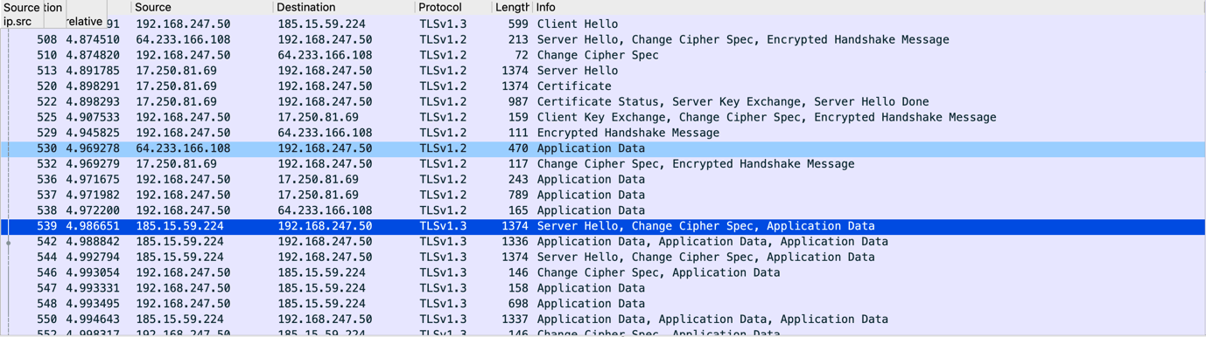
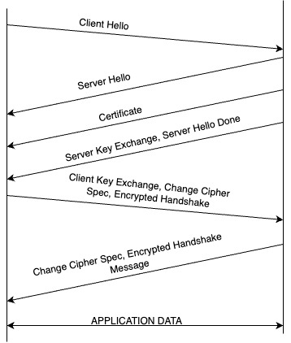
Diagram displaying the TLS Handshake Steps
Server
Client

- Client Hello: Client sends hello to server of the length 524, using TLSv1.3 Protocol. This contains all the cryptographic algorithm and other parameters supported by the client. In this case there are 16 cipher suites. Client also shares a random encrypted value.
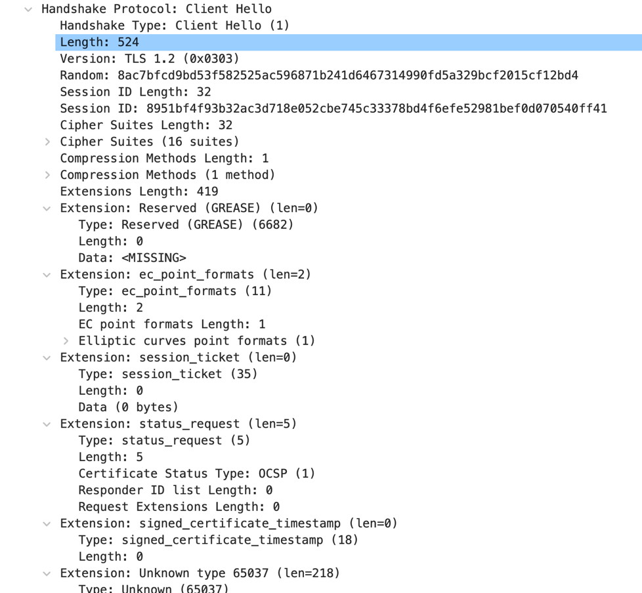

- Server Hello: Server responds the client and establishes a connection and shares the chosen cryptographic algorithms. Server selected TLS_AES_256_GCM_SHA384 suite.
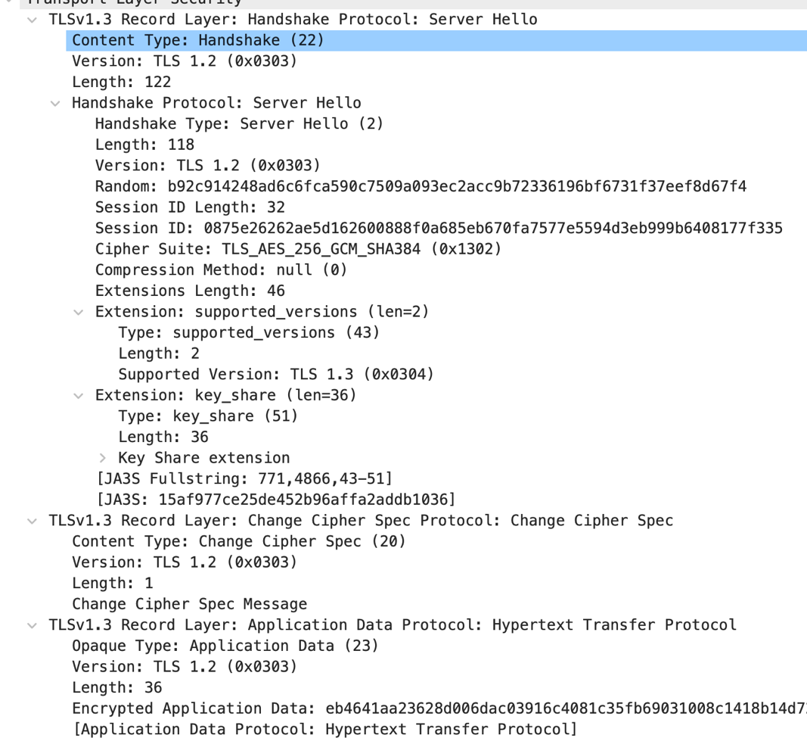
- Certificate and Server Key Exchange: server shares the certificate and public key to proof its validation. Server Key Exchange also contains information of type and parameters of protocol followed. In this case Diffie-Hellman.

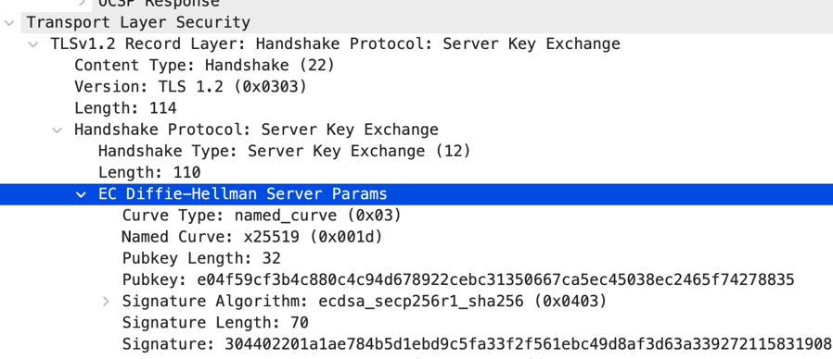

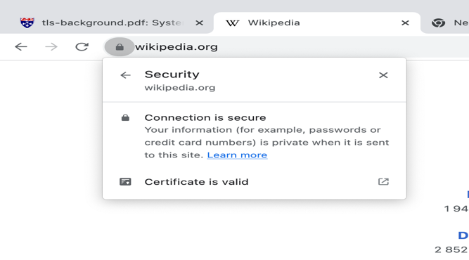

- Change Cipher Spec: Both client and server signal the start of transition to encrypted communication.

Time Taken by the chosen URL, “Wikipedia.org”, TLS handshake to establish a connection 0.123 seconds for a total session time recorded of 105.9 seconds.

Longer time span (3 to 5 years) of a TLS Certificate means that the hackers get more time to forge malware or phishing attacks using the bogus or compromised certificate.

Appropriate time span of a certificate: Currently, Apple, Mozilla and Google allow a 378-day validity. Google announced that it is further going to reduce the time span to 90 days to make the networks more secure. [1] [2]

Constraints on shortening the TLS Certificate Lifecyle: The websites owners need to make sure to update the certificate on time, otherwise it will lead to a huge financial and user traffic loss. Developers need to spend time automating the TLS certificate renewal, provisioning and installation. The number of devices is increasing significantly, and reduced lifespan would require more certificates per device. Enterprises are distributing many certificates, but a greater number of certificates means harder to maintain record of the identities of the certificate distributed.

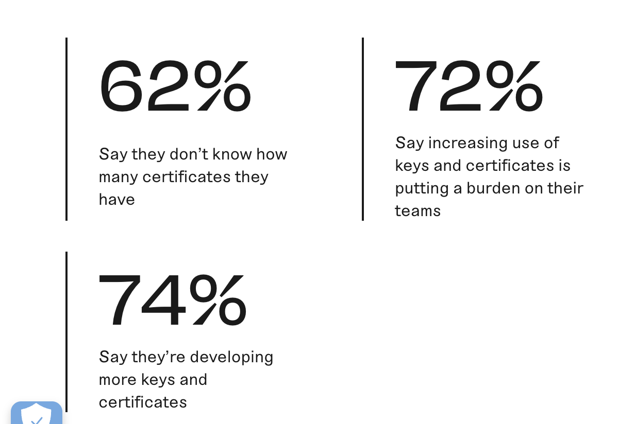

Surveying enterprises distributing certificates [4]

Part 2. BEAST Attack (Browser Exploit Against SSL/TLS)
This attack exploits vulnerability in the TLS version 1.0 and older using cipher block chaining mode encryption. The attack was first executed in 2011 by Thai Duong and Juliano Rizzo. Beast attack makes use of protocol downgrade attack and man-in-the-middle attack techniques. The attacker can tap into the communication, and if the plain text is not encrypted, it can read all the data like passwords, credit card information. If the text is encrypted using downgrade technique it brings down the TLS version used to 1.0 or older. The client may offer the 1.3 version during handshake, and server responds with 1.0, then client will find a common version available for communication. In this way the version can be downgraded and attacker can exploit vulnerabilities in CBC and decrypt the plain text.

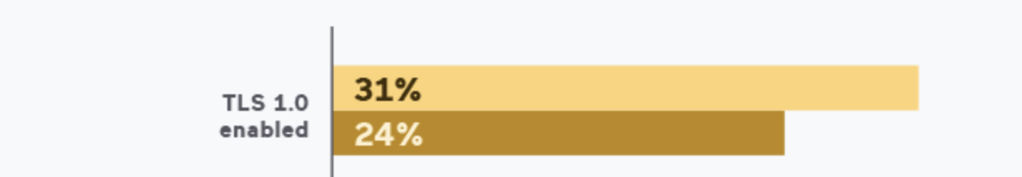

Servers with TLS enabled according to a 2020 study [5]

CBC uses XORing to encrypt keys and this process can be reversed to obtain the key. Attacker can just needs guessed plain text, previous cipher text and initialization vector (from previous message), refer diagram below.
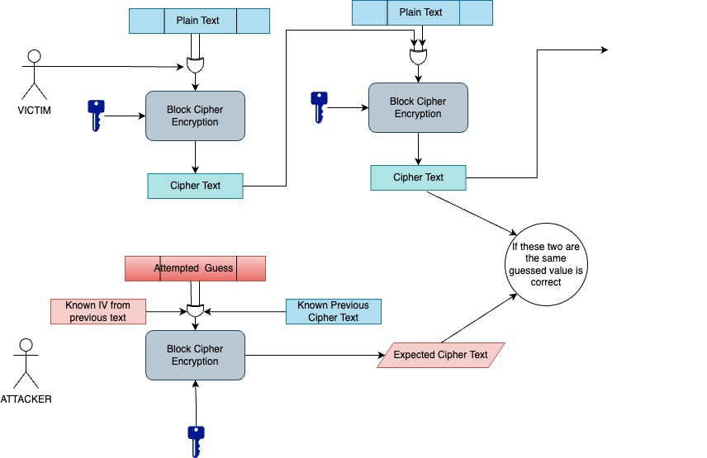

Counter Measure
- To mitigate the BEAST Attack from the server side, older versions – v1.0, v1.1 should be disabled as all major browsers support v1.2
- And on the client side (when older versions cannot be blocked) there is a 0/n split approach, where a blank message is sent before which will generate an unpredictable IV. This approach was followed by Google but was inefficient as many servers would see this as End Of File value. [3]
- To fix this Firefox devised a 1/n-1 split approach where the client will first share only the first letter of the message and then the rest. In this approach the first letter can be read by the attacker but rest of the message will be secured.

QUESTION – 2
Introduction
The report highlights security threats and corrective policies taken for a greenhouse farm equipped with IOT machines to optimize crop cultivation, resource utilization and environmental conditions.
Part 1. THREAT MODEL
- Spoofing:

There can be an attack by impersonating the authorized workers. This attack can give adversaries like competitors, government or state sponsored groups (to gain advantage in agricultural sector) access to the farm’s IOT based architecture. The adversary can procure the credentials or biometrics’ copy of the authorized people and log into the system.

- Malicious Attacks by Authorized Person: There can be an intentional (for personal gain) or unintentional compromise of the security of the systems or functionality or data leakage by someone who is authorized to access the IOT devices and all its functionalities.
- Privacy Risk: The attackers like competitors can see the precise location and identity of the devices. All the data regarding the temperature, amount of water, soil composition etc. is collected by IOT devices, which can be accessed by the attacker to reveal the farmers nutrient solution adopted and physical activities. With all this information the adversary can initiate an attack by suitable means.
- Tampering: Adversaries like robbers, jealous relatives, competitors or hackers can tamper with the device in person or online, to change the behavior of the machine. For example, the amount of water supplied can be decreased, or the machine can be set to detect food ripening earlier than it ripens.
- Denial of Service (DOS) Attack:

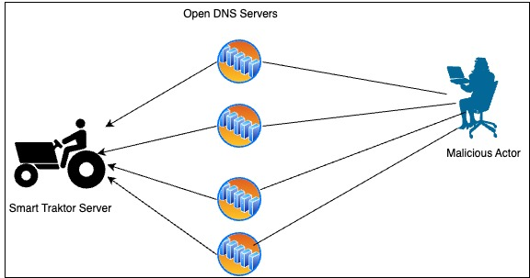

The adversaries can launch a DOS attack by overloading the IOT server with data leading to the machines not working for some time and financial losses for the farmers.

Part 2. SECURITY POLICY
- Access Control: Employees should be given access to only that part of the machinery and data that is utmost necessary for their work. For example, most farmer employees in the farm should not be able to get access to the solution opted by owner to improve soil fertilization.
- Physical Tamper Proofing: Keep the devices in tamper-proof and weatherproof boxes with controlled access to prevent intentional or unintentional damage to the devices.
- Security Protocols: Store data online by converting data to ciphertext like Encryption, Hashing, salting. Implement security protocols like Transport Layer Security (TLS) to communicate between channels.

- Regular Auditing and Monitoring: All the IOT agricultural machines should be regularly checked, and continuously monitored to identify any breach in security and take corrective measures as soon as possible. Have an anomaly detection planned out.
- Authentication Methods: Behavioral based biometric authentication and 2-Factor Authentication should be utilized to enhance the security of the IOT farm.
- Methods to prevent DOS Attacks: Below methods have been implemented to prevent overloading of IOT farm servers:
  - Blocking Known Malicious Sources: Blocking the IP addresses of the sources priorly known or suspected to be malicious can reduce chances of DOS attack.
  - Rate Limit: Have a limit on the number of servers accessing the machines according to requirement.
  - Addition of firewalls and segmented networks: Break the networks into multiple small segments by adding VLANs and firewalls. This will prevent spread of the DOS attack throughout the IOT farm.

Part 3. ANOMALY DETECTION SYSTEM FOR IOT GREENHOUSE FARM
This report contains the key security metrics and how to detect anomalies in them to protect against attacks.

Network Security:
By monitoring the network traffic, one can figure out sudden changes in pattern or something out of ordinary. In the below figure, the normal communication between networks is in the box and suddenly all the servers start connecting with an unknown server.
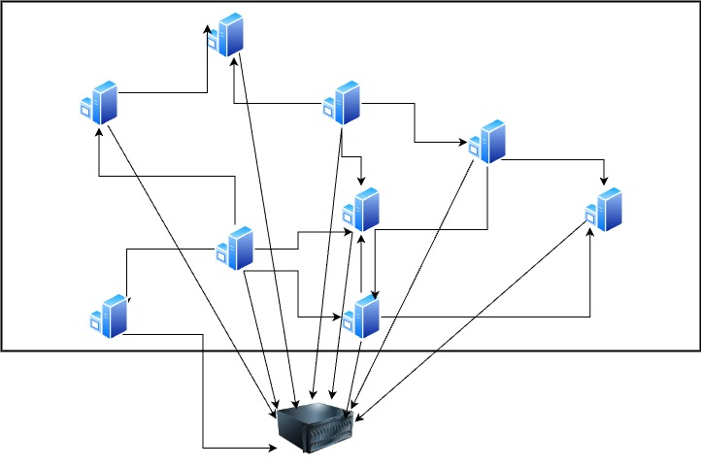
But as an IOT farm has a lot of machines to carry out operations and data is being collected at all times, there huge amounts of data to be collected. Storing this much data will be infeasible. The proposed solution to efficiently monitor and timely find any attacker is to sample the monitoring process based on time and flow.

- Flow based: Network should be monitored for communication between devices, for example it is a very sunny day, the machine checks the greenhouse temperature and finds it to be above required levels, it communicates this to the harvester machine. This is a perfect example communication scenario to monitor the traffic.

- Time Based: There is a chance of missing out on attackers when there is no communication in flow-based monitoring. Additionally, monitoring should be set up for regular intervals. Specially for the time important tasks are being carried out like greenhouse harvester machines picking up ripened crops, automation irrigation systems working and soil PH maintenance. This will bring a structured approach whist covering the important tasks.

A combination of both these sampling methods will reduce the amount of traffic data captured and at the same time making sure that the necessary functions are being carried out correctly.
A system will be set up to report and alert the owner of the farm if any anomaly is found.

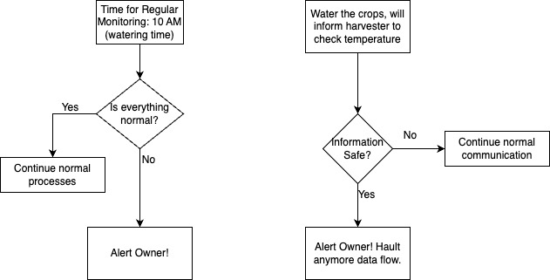

User Behavior: recognize unusual user behavior and unauthorized login attempts or attempts to restricted areas.

Device Behavior: identify number of times a device deviates from expected behavior and figure out anomaly according to the deviation value and number of times.

Strengths: The system proposed addresses the concern of efficient network data management and makes sure monitoring takes place where it is most needed. This approach is structured and comprehensive as it covers network, user and device behavior with an alerting mechanism for quick investigation.

Weaknesses: The attacker might sweep into the system in the gaps in monitoring and dependency on sampling can be dangerous. Also, it does not address the scalability planning of this approach as the number of machines grow. While identifying anomalies in user and device behaviors there can be potential false positives and false negatives (example A farmer forgets the password or got a cut on his finger can be identified as an anomaly).

QUESTION – 3

5 STRENGTHS

- Strong Password Criterion: The requirements for password to be 8 or more characters long, containing random capitalized, special characters and numbers interspersed, and something not in the dictionary. Additionally, the password should not be any data associated with the user. Enforcing this with password strength checker, leads to creation of a robust password.
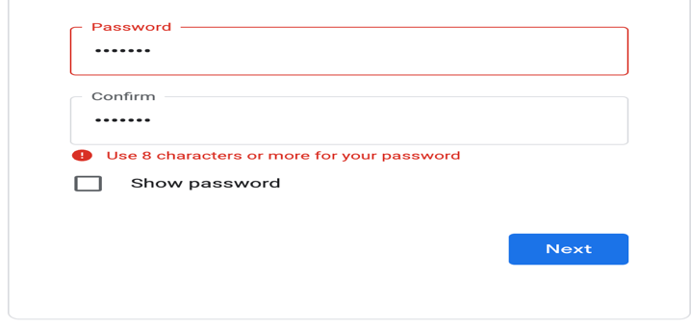

- Password Change Policy: Clearly outlining situations where changing a password is recommended, such as suspicion of compromise or removing malware from system, empowers users to take proactive measures in response to potential security threats.
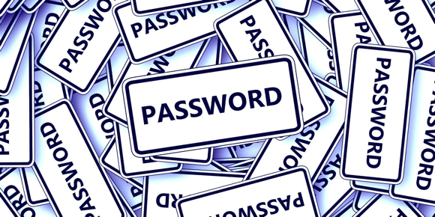
How do I remember all this again after 6 months?

- Phishing Information: PayPal has warned users about phishing and has provided information on how to spot phishing and how instead of clicking links in emails, directly go the PayPal site and change the password
- Managing Multiple Passwords Suggestion: PayPal understands that humans cannot remember so many unique and difficult passwords and hence suggests a policy to manage unique passwords.
- Emphasis on Unique Password: PayPal asks users to have a unique password, highlighting the risks of not doing so.

5 WEAKNESSES

- Usage of Password Keeper App: it is better to have the password written on paper as smart phones are prone to hacking or data leakage. For Example. There was a cyber security attack on ‘LastPass’, a password storage app and millions of user’s sensitive data was leaked.
- Common Part of Passwords: There can be two ways this technique weakens the password strength. First, if the attacker gets hold of two of the user’s passwords, they’ll find the common part of the password, it will reduce the strength of the password used and will take less time to decrypt and figure out the unique part. Second, if the attacker gets access to the unique password list, the common part of password will be easily guessable giving them access to all the secure sites.
- ‘PayPal Asks you to Change your Password’: This might lead to users getting caught in phishing attacks. There is no specification on why and when PayPal would ask to change the password.

PayPal is asking to change password – ‘CLICK LINK’

- Reliability on Security Questions: Answers to security questions for changing the password are easily guessed or this information is readily available online.
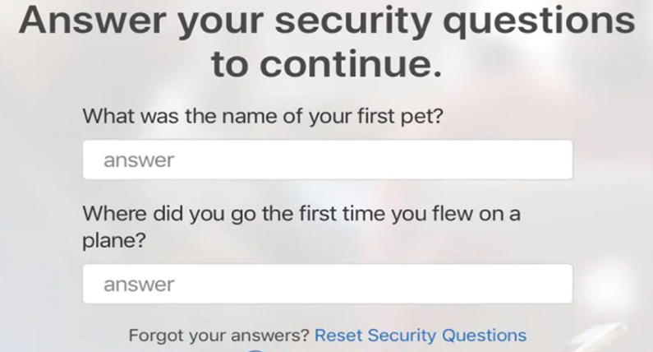
Lord Chesterfield

- Lack of Stronger Authentication methods: There should be better authentication methods like 2-Factor Authentication by receiving OTP on mobile or email.

Bibliography

[1] | R. Lakshmanan, "thehackernews.com," 1 September 2020. [Online]. Available: https://thehackernews.com/2020/09/ssl-tls-certificate-validity-398.html.
[2] | Google, "Moving Forward, Together," The Chromium Projects, 03 03 2023. [Online]. Available: https://www.chromium.org/Home/chromium-security/root-ca-policy/moving-forward-together/.
[3] | D. Wong, "1/n-1 split to circumvent BEAST," [Online]. Available: https://www.cryptologie.net/article/378/1n-1-split-to-circumvent-beast/.
[4] | Key Factor, "State of Machine Identity Management 2023," 2023. [Online]. Available: https://www.keyfactor.com/state-of-machine-identity-management-2023/.
[5] | Acunetix, "2020 Acunetix Web Application Vulnerability Report," [Online]. Available: https://www.acunetix.com/white-papers/acunetix-web-application-vulnerability-report-2021/#tls-ssl-vulnerabilities.

